# GOVERNMENT ARTS COLLEGE, OOTY

# DEPARTMENT OF MATHEMATICS

# Mentor: Dr. N. Anusheela

## Team Leader: Deepa. R

## Team Member 1: Dhinesh Kumar. S

## Team Member 2: Karthikeyan. J

## Team Member 3: Sabeen Kumar. A

# BUILD A EMPLOYEE TRAVEL APPROVAL APPLICATION FOR CORPORATES

# 1: INTRODUCTION

# 1.1 OVERVIEW:

A travel approval application is a formal request made by an employee or a group of employees to their organization's management seeking permission to travel for business purposes. The purpose of the application is to outline the details of the proposed trip, including the purpose of the trip, the itinerary, the dates of travel, the expected expenses, and the expected benefits to the company.

This section outlines the reason for the trip and the expected benefits to the company. It should explain why the travel is necessary and how it will contribute to the company's goals.This section includes the travel dates, destination(s), mode(s) of transportation, and any other relevant details about the travel logistics.

This section provides an estimate of the total cost of the trip, including transportation, accommodation, meals, and any other expenses associated with the trip.This section provides a detailed breakdown of the estimated costs and explains how each expense is necessary to achieve the objectives of the trip.This section outlines the approval process for the travel request, including who needs to approve the request and the timeline for approval.

This section confirms that the employee(s) have read and understood the company's travel policies and will adhere to them during the trip. The application must be signed by the employee(s) and their supervisor(s) to confirm that they have reviewed and approved the travel request.

Overall, a well-prepared travel approval application provides the company's management with the necessary information to make an informed decision about approving the employee's travel request.

# 1.2 PURPOSE:

A travel approval application is typically used by employees to request permission from their employer or supervisor to travel for business purposes. The purpose of the application is to ensure that the travel is necessary and authorized by the company, and that any expenses associated with the travel are within budget and in line with company policy.

The application should include information such as the purpose of the trip, the dates of travel, the expected cost of the trip, and any other relevant details. The employer or supervisor will review the application and decide whether to approve the travel or not.

Travel approval applications are important for ensuring that business travel is necessary and beneficial for the company, and that it is carried out in a responsible and cost-effective manner. By requiring employees to obtain approval for travel, companies can also better manage their travel budgets and ensure that resources are used wisely.

# 2: PROBELM DEFINING & DESIGN THINKING

# 2.1 EMPATHY MAP:

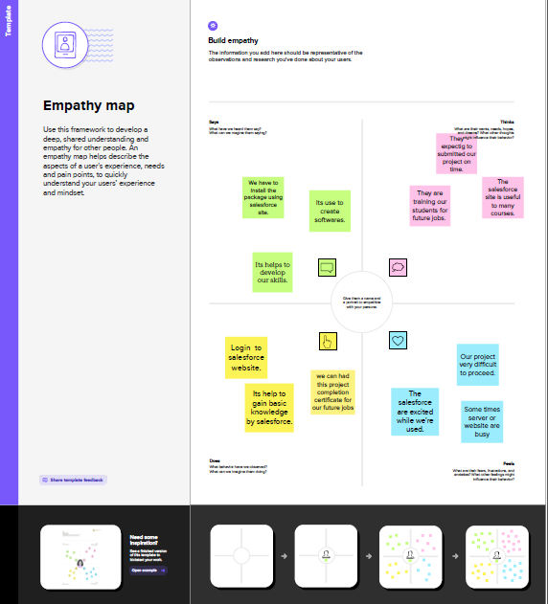

# 2.2 IDEATION AND BRAINSTROMING MAP:

# BrainStroming.png

# 3: RESULT

# 3.1 DATA MODEL:

|  |  |  |
| --- | --- | --- |
| OBJECT NAME | FIELD LABEL | DATA TYPE |
| Department | Amount | Currency |
| Travel Approval | Travel Approval | Master- Detail Relationship |
| Expense Item | Expense Type | Picklist |

# 3.2 ACTIVITY & SCREENSHOT

# Milestone: 1

Creation of Developer Account

# Description:

We had created a new salesforce developer account from the website Developer.salesforce.com

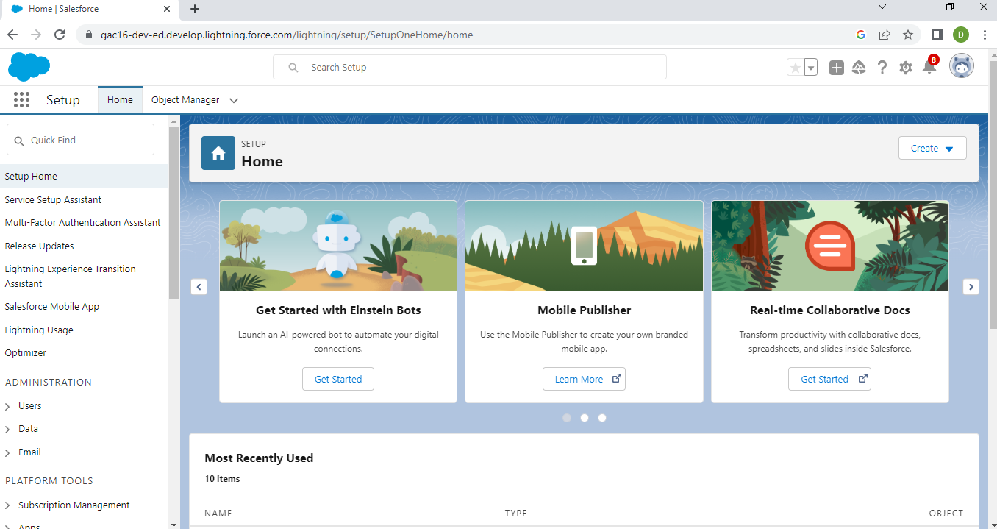

# Milestone: 2

Create the Travel Approval Application

# Description:

We had create the travel approval application in new lightning app.

# 2.png

# Milestone: 3

Custom Object Creation.

# Description:

We had created a three custom object named”Depaartment, Travel Approval, Expense Item”’with given data type.

# 3.png

# Milestone:4

Create the Tabs

# Description:

We had created a tab with the tab style Bridge.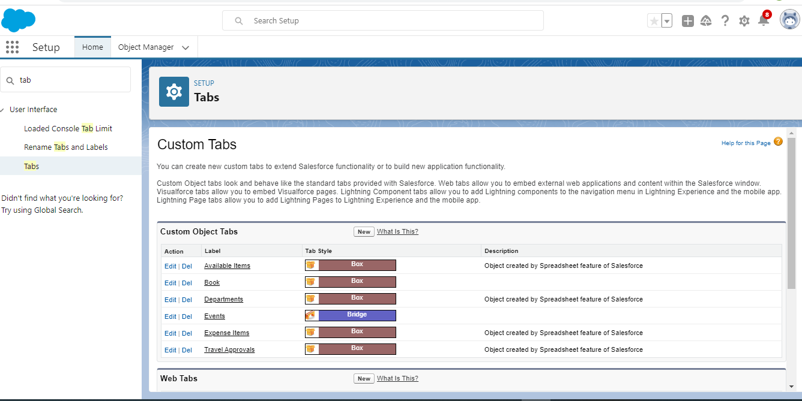

# Milestone:4

Create Fields & Relationships

# Description:

We had created the field names” Amount, Travel Approval, Expense Type” object.

# 4.png

# Milestone:5

Import Departments

# Description:

We had download the document and add the new records and summary data we start import.

# 5.png

# Milestone:6

Create User and Setup Approvals

# Description:

We create the new user and give it role CEO . The user account in the list provided.

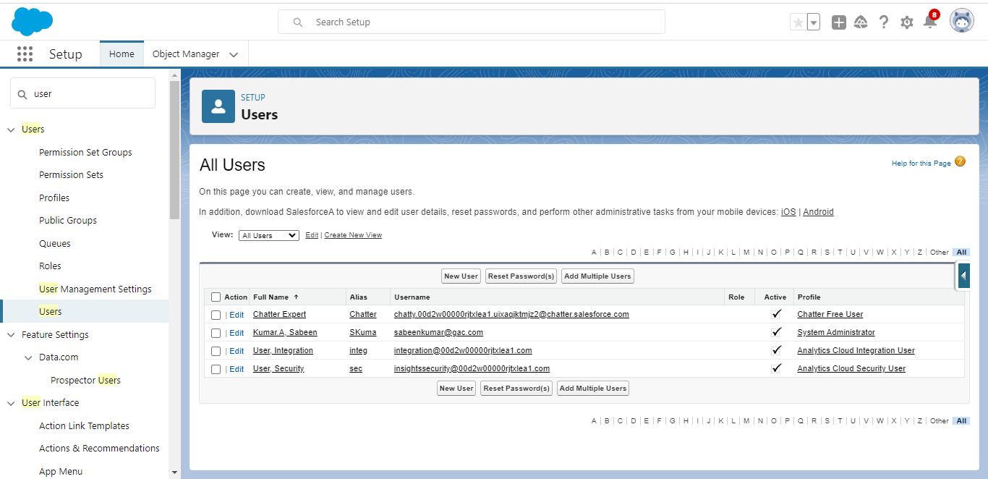

# Milestone:7

Customize Travel Approval Object Page layouts

# Description:

Customization refers to custom software development and coding to add robust features to our CRM platform.These features can be integrated with our business to have a scalable impact.

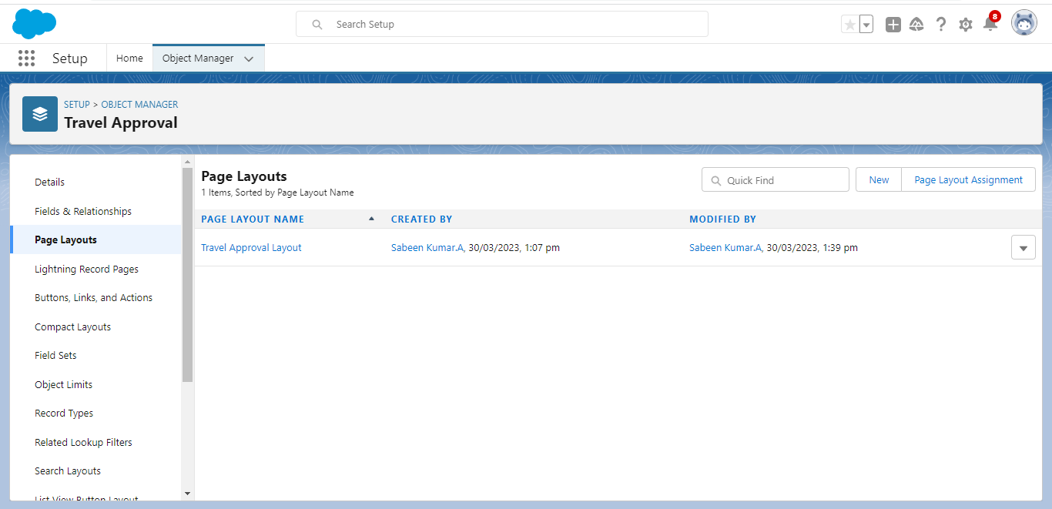

# Milestone:8

Add business logic to travel app

# Description:

In this milestone we are create the validation rules, rollup summary fields, formula fields, workflows and approval process.

# 8.png

# Milestone: 10

Reports

# Description:

We had created a report for review and Travel Approval Objects.

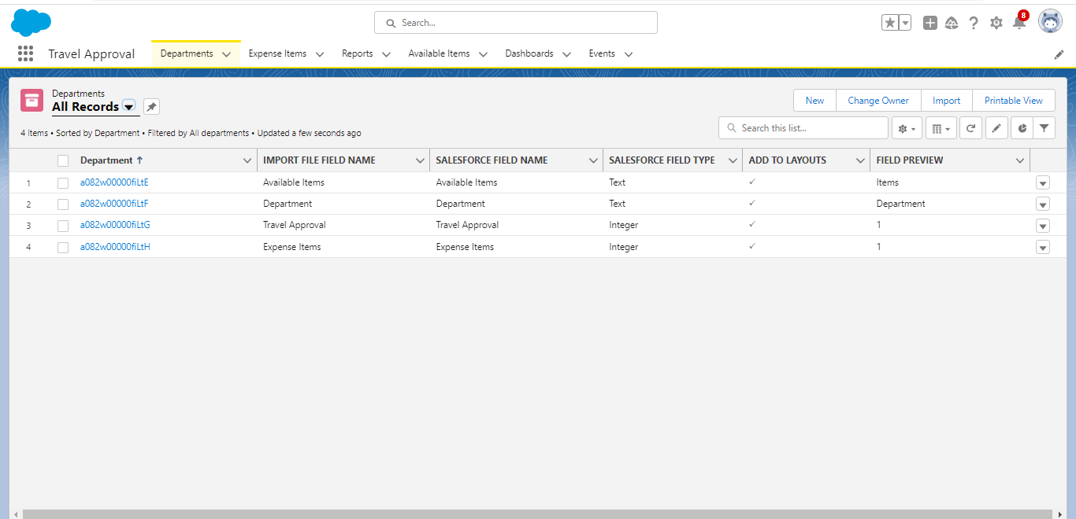

# Milestone: 11

Dashboards

# Description:

We had created a Travel Approval Dashboard.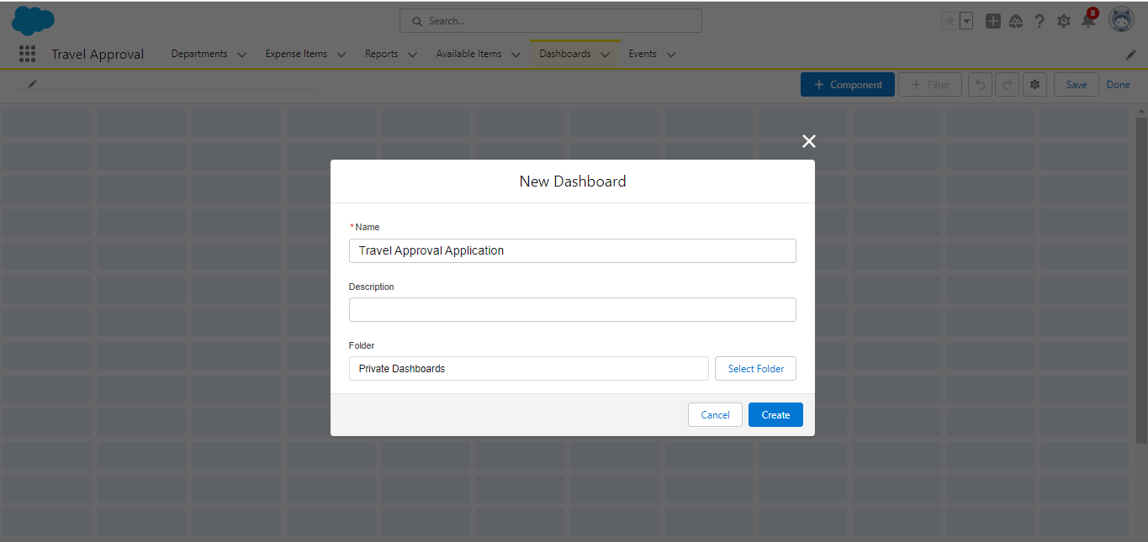

# 4: TRAILHEAD PROFILE PUBLIC URL

## Team Lead: <https://trailblazer.me/id/deepasaranya>

## Team Lead 1: <https://trailblazer.me/id/dkumars29>

## Team Member 2: <https://trailblazer.me/id/karthija>

## Team Member 3: <https://trailblazer.me/id/skumara96>

## 5: ADVANTAGES & DISADVANTAGES OF THE PROJECT

Travel approval applications, also known as travel request systems, are used by organizations to streamline the process of requesting and approving employee travel

## ADVANTAGES:

Travel approval applications can make the process of requesting and approving travel simpler and more streamlined. Employees can easily submit their travel requests and managers can quickly approve or deny them.

Travel approval applications can reduce errors in the travel approval process by automating the approval process and eliminating the need for manual data entry. Travel approval applications can provide better control over travel expenses by allowing managers to set travel budgets and approve travel expenses before they are incurred.

Travel approval applications can provide real-time tracking of travel requests and approvals, which can help managers better manage employee schedules and travel plans.

## DISADVANTAGES:

Travel approval applications can be expensive to implement and maintain, especially for smaller organizations with limited budgets.Employees may need to be trained on how to use the travel approval application, which can take time and resources.

Technical issues with the travel approval application can cause delays in the travel approval process and result in frustration for employees and managers. Travel approval applications may have limited flexibility, which can be frustrating for employees who need to make changes to their travel plans.

Overall, the advantages of travel approval applications generally outweigh the disadvantages, especially for larger organizations with complex travel needs. However, organizations should carefully evaluate the costs and benefits of implementing a travel approval application before making a decision.

# 6:APPLICATIONS

Before you can implement a travel approval application, you need to define your organization's travel policies. This includes setting travel budgets, defining approval workflows, and determining what types of travel expenses are reimbursable.

There are many different travel approval applications available, each with its own features and pricing. Do your research to find an application that meets the needs of your organization and fits within your budget. Before rolling out the application to your entire organization, it's a good idea to test it with a small group of employees. This will help you identify any technical issues and ensure that the application is user-friendly.

Once you've selected and tested the travel approval application, you'll need to train your employees on how to use it. Provide clear instructions and offer support to ensure that everyone is comfortable using the application.

Once everyone is trained, you can roll out the application to your entire organization. Be sure to communicate any changes to your travel policies and provide ongoing support to ensure that the application is being used effectively.

Finally, monitor usage of the travel approval application to ensure that it's being used effectively and that travel expenses are being managed appropriately. Make adjustments as necessary to ensure that the application continues to meet the needs of your organization.

# 7: CONCLUSION

In conclusion, a travel approval application can bring many benefits to an organization. It simplifies the process of requesting and approving employee travel, reduces errors, provides better control over travel expenses, and offers real-time tracking of travel requests and approvals. However, there are also potential disadvantages, such as cost, a learning curve for employees, technical issues, and limited flexibility.

Before implementing a travel approval application, it's important to define your organization's travel policies, research different applications, test the application with a small group of employees, train everyone on how to use it, and monitor usage to ensure it's being used effectively. Overall, a travel approval application can be a valuable tool for managing employee travel and expenses, but it's important to weigh the costs and benefits and choose the right application for your organization's needs.

# 8: FUTURE SCOPE

Travel approval applications will likely integrate with other travel management tools, such as expense management systems, travel booking platforms, and travel risk management tools. This integration will enable a seamless travel management experience for employees and managers, from booking travel to submitting expenses.

As more employees work remotely or on-the-go, travel approval applications will need to be accessible from mobile devices. This will enable employees to submit travel requests and managers to approve them from anywhere, at any time.

Travel approval applications may increasingly use artificial intelligence and automation to simplify the travel approval process. For example, AI-powered tools can automatically approve travel requests that fall within predefined parameters, while leaving more complex requests for manual review.

Travel approval applications will provide real-time data and analytics to enable better decision-making. This data can include information on travel spend, employee travel patterns, and potential travel risks.

Travel approval applications will increasingly offer customization options, allowing organizations to tailor the application to their specific needs. This can include the ability to set custom approval workflows, create custom reports, and integrate with other internal systems.

Overall, the future of travel approval applications is likely to focus on simplifying the travel approval process, increasing mobility, leveraging artificial intelligence, providing real-time data and analytics, and offering customization options.